1)A)
Index.html
<html>
<head>
<title>Multiplication Table Generator</title>
<style>
body {
font-family: Arial;
text-align: center;
margin-top: 50px;
}
#output {
margin-top: 20px;
font-size: 18px;
}
</style>
</head>
<body>

<h1>Multiplication Table Generator</h1>
<button onclick="generateTable()">Generate Table</button>
<div id="output"></div>
<script src="server.js"></script>

</body>
</html>

Server.js
function generateTable() {
var num = prompt("Enter a number:");
var outputDiv = document.getElementById("output");
num = Number(num);
var result = "<h3>Table of " + num + "</h3>";
for (var i = 1; i <= 10; i++) {
result += num + " x " + i + " = " + (num * i) + "<br>";
}

outputDiv.innerHTML = result;
}
Output:-
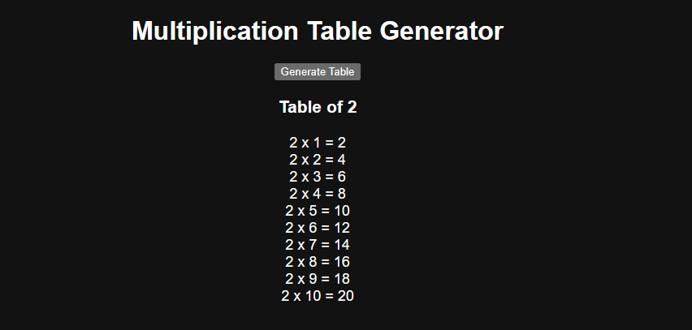

1)b)
Program:-
Selector.html
<html >
<head>
<title>Element Selectors Example</title>
<style>
.highlight {
color: green;
font-weight: bold;
}
</style>
</head>
<body>

<h1 id="mainHeading">Hello from Heading</h1>
<p class="highlight">This is a paragraph with a class.</p>
<p>This is a paragraph with a tag selector.</p>
<button onclick="selectElements()">Select Elements</button>
<script>
function selectElements() {
// Select by ID
var heading = document.getElementById("mainHeading");
heading.style.color = "blue";

// Select by Class
var highlightPara = document.getElementsByClassName("highlight")[0];
highlightPara.innerHTML = "Class selected and changed!";
// Select by Tag
var firstPara = document.getElementsByTagName("p")[1];
firstPara.style.fontStyle = "italic";

// Select using querySelector
var h1 = document.querySelector("h1");
h1.innerHTML += " [Modified]";
}
</script>

</body>
</html>
Output:-
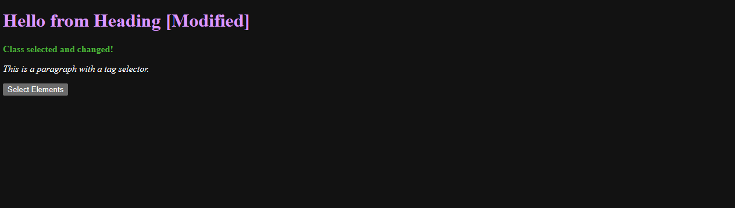
1)c)
Program:-
Event.html
<html >
<head>
<title>Event Listener Example</title>
<style>
body {
font-family: Arial, sans-serif;
text-align: center;
margin-top: 50px;
}
#message {
margin-top: 20px;
font-size: 18px;
color: green;
}
</style>
</head>
<body>

<h1>JavaScript Event Listener Demo</h1>
<button id="myButton">Click Me</button>
<div id="message"></div>

<script>

var button = document.getElementById("myButton");
var message = document.getElementById("message");
button.addEventListener("click", function() {
message.innerHTML = "You clicked the button using an event listener!";
});
</script>

</body>
</html>
Output:-


1)d)
Aim:-
Program:-
Clickevent.html
<html>
<head>
<title>Click Event Handler</title>
<style>
body {
font-family: Arial, sans-serif;
text-align: center;
margin-top: 40px;
}
button {
margin: 10px;
padding: 10px 20px;
font-size: 16px;
}
#output {
margin-top: 20px;
font-size: 18px;
color: blue;
}
</style>
</head>
<body>

<h1>Click Event Handling Example</h1>
<button id="btn1">Say Hello</button>
<button id="btn2">Show Time</button>
<button id="btn3">Clear Message</button>

<div id="output"></div>

<script>
const btn1 = document.getElementById("btn1");
const btn2 = document.getElementById("btn2");
const btn3 = document.getElementById("btn3");
const output = document.getElementById("output");

btn1.addEventListener("click", function() {
output.innerHTML = "Hello, welcome to JavaScript!";
});

btn2.addEventListener("click", function() {
const now = new Date();
output.innerHTML = "Current time: " + now.toLocaleTimeString();
});

btn3.addEventListener("click", function() {
output.innerHTML = "";
});
</script>

</body>
</html>
Output:-


1)e)
Program:-
Function.html
<html>
<head>
<title>JavaScript Function Types</title>
<style>
body {
font-family: Arial;
text-align: center;
margin-top: 40px;
}
button {
margin: 10px;
padding: 10px 20px;
}
#result {
margin-top: 20px;
font-size: 18px;
}
</style>
</head>
<body>

<h2>JavaScript Function Types Demo</h2>
<button onclick="greetUser()">Function Declaration</button>
<button onclick="calculateSum()">Function defination</button>
<button onclick="showDate()">Arrow Function</button>

<div id="result"></div>

<script>

function greetUser() {
document.getElementById("result").innerHTML = "Hello from a Function Declaration!";
}
var calculateSum = function() {
let a = 5, b = 7;
document.getElementById("result").innerHTML = "Sum (Function Expression): " + (a + b);
};
var showDate = () => {
let today = new Date();
document.getElementById("result").innerHTML = "Today's Date: " + today.toDateString();
};
</script>

</body>
</html>
Output:-
